CprE 419 Lab 1: Using the Cluster, and Introduction to HDFS

**Shuo Wang**

# Experiment 1 (10 points):

Create a directory called /user/<your login id>/lab1 under HDFS. Create a new file called “afile.txt” on your local machine with some text (make me laugh). Then use WinSCP (or ssh on linux) to move the file to your home directory in Cystorm. Use a *hdfs dfs* command to move this file to the directory you created. Show this to the instructor.

1. Create a new directory



2. Create “afile.txt” and move it to Cystorm:

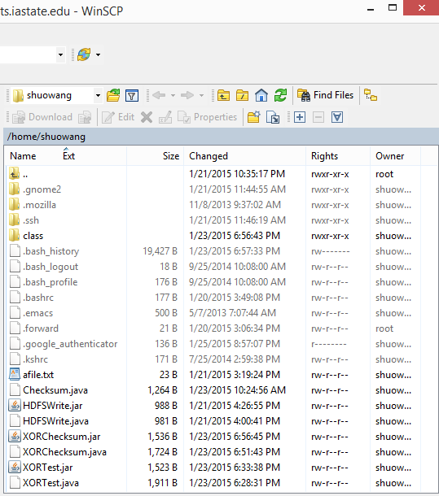

2. Use a *hdfs dfs* command to move this file to the directory you created



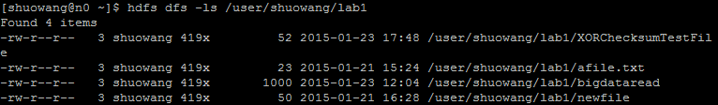



**Experiment 2 (40 points):**

Write a program using the Java HDFS API that reads the contents of the HDFS file “*/class/s15419x/lab1/bigdata*” and computes the 8-bit XOR checksum of all bytes whose offsets range from 5000000000 till 5000000999, both endpoints inclusive. Print out the 8-bit checksum.

Attach the Java code in your submission, as well as the XOR output.

For instance, the XOR checksum of the bitstring “00000000111111110000000011111111” is “00000000”.

1. Java code:

import java.io.*;

import java.lang.*;

import java.util.*;

import java.net.*;

import org.apache.hadoop.fs.*;

import org.apache.hadoop.conf.*;

import org.apache.hadoop.io.*;

import org.apache.hadoop.util.*;

public class XORChecksum {

public static void main ( String [] args ) throws Exception {

// The system configuration

Configuration conf = new Configuration();

// Get an instance of the Filesystem

FileSystem fs = FileSystem.get(conf);

String path_name = "/class/s15419x/lab1/bigdata";

Path path = new Path(path_name);

// Open File for reading

FSDataInputStream in = fs.open(path);

// Create buffer to store data

byte[] buffer = new byte[1000];

// Read all bytes whose offsets range from 5000000000 till 5000000999 from File into buffer.

long location = 5000000000L;

int offset = 0;

int length = 1000;

int bytesRead = in.read(location,buffer,offset,length);

System.out.println("start byte #: " + Long.toString(location));

System.out.println("Number of bytes read: " + bytesRead);

// Initiate xorChecksum

byte xorChecksum = 0;

// Create loop to compute xor byte by byte

for (byte b:buffer)

{

xorChecksum ^= b;

}

// Display the byte XORChecksum and the 8-digit XORChecksum

System.out.println("byte XOR Checksum: " + xorChecksum);

System.out.println("8-digit XOR Checksum: " + String.format("%8s", Integer.toBinaryString(xorChecksum & 0xFF)).replace(' ', '0'));

// Close the file and the file system instance

in.close();

fs.close();

}

}

2. output result

